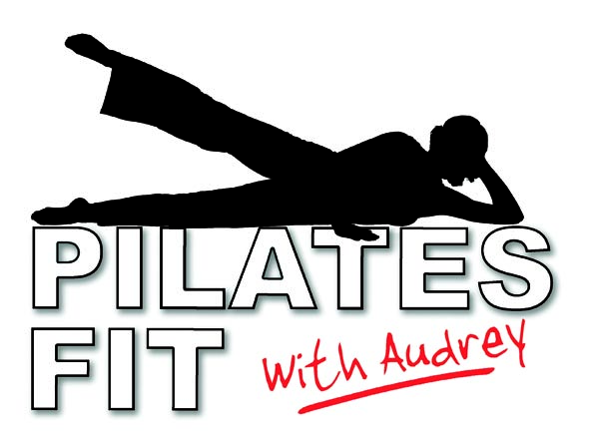
Courses February/March 2023

Course /Day Time Venue Length Cost
A: Tuesday 6.15 – 7.15 pm Oakfield 6 weeks £54
Course dates: Feb 21, 28: Mar 07, 14, 21, 28
***************************
B: Thursday 6.15 – 7.15 pm St Mary 6 weeks £54
Course dates: Feb 23: Mar 02, 09, 16, 23, 30
***************************

If you are unable to make a class for any reason, you can attend the other class so you won’t miss out!
If space is available, you can start a course at any point and just pay for the remaining weeks
Payment can be made;
1. By cheque made payable to FIT FOOTWEAR or with cash at the first session
2. By credit/debit card at Fit Footwear, 16-18 Seale Street, St Helier
3. By PayPal at http://www.fitfootwearcentral.co.uk/pilatesfit.php
4. By Bank transfer: Fit Training and Footwear Limited sort code: 30-94-61 a/c 04870311

NAME:…………………………………………………………………………………….TEL. NO. ………………………………………………

E-MAIL ADDRESS:…………………………………………………………………………………………………………………………………

DAY/VENUE/TIME:………………………………………………………………………………………………………………………………

DISCLAIMER: I realise that my teacher is trained and fully insured but I accept responsibility for any injuries that may occur whilst taking part in a class.

SIGNED…………………………………………………………………………………………DATE:…………………………………………………

