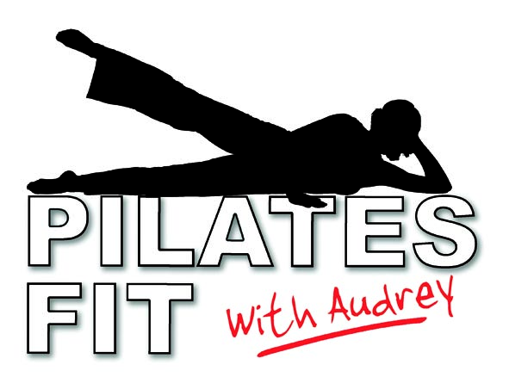
INFORMATION AND TIPS

+ You will need your own mat (a yoga mat is ideal) for all classes
+ Please bring a bottle of still water, and a hand towel may be useful
+ Wear loose, comfortable clothing- no shoes necessary
+ In Autumn/Winter bring an extra top layer to put on during the relaxation
+ Don’t eat for at least an hour before the class
+ If seeing a chiropractor/physiotherapist, please check that they are happy for you to take part in a class
+ These are group classes so may not be suitable if you have a serious back problem
+ Pilates FIT classes have a unique format! The exercises vary every week so you will never get bored
+ The classes are suitable for all. Exercises start at a beginner’s level but you will be given options to make the exercises more intense if you feel you can work harder.
+ Most benefit is gained if you attend regularly. You are welcome to make up for any missed classes by attending a different session

